1.2 Algorithm
When we first discussed the assignment, we decided on which classes we should make. We needed to make a “card” class, it should contain the different properties of each card, it should be able to pick a SET from twelve cards and it needed to be able to check if three cards are a SET. but that’s all we could come up with, because these are all the calculations that needed to be done. So we started with making a class for the cards in python. Before we could make this class, we should first decide on how to memorize and calculate the cards. We decided on lists, because we are familiar with lists and they are easy to work with. A card consists of four properties, we can show these properties with numbers from one to three. This is how we defined each property:
Properties: | Colour: | Shape: | Shading: | Number:
1 | Green | Diamond | Empty | One
2 | Purple | Oval | Filled | Two
3 | Red | Squiggle | Shaded | Three

A list as [1, 1, 1, 1] is equal to the card with one green empty diamond, we give a string name to such a list. In the example above the string name is ‘greendiamondempty1’. We need this for later in the code, because these are the names of the images. Therefore we decided to assign the list for the card and the string name for the card to each card. An example of an possible card would be the following: . We decided to put both definitions in the list for each card, because then the list name and string name are coupled with each other. We can define calculations on the list name of each card and we can use the string name to load images of the card.

Class Card
The class for the cards starts with the initialization: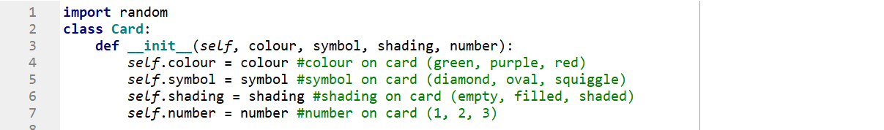
We define the colour, symbol, shading and number for the card. We first made an easy string function to create the string name of the card:
This just puts the properties of each card in the right order. Now we defined a function for checking if three given cards are a SET:
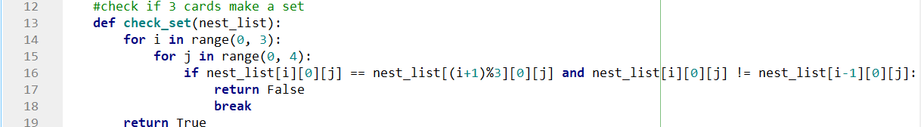
Here the input consists of an nested list, because there are three cards given and the cards are lists. An example of an input is:

We check if three cards make a set by checking if the three cards do not make a SET, basically our check works on the fact that if the first card is green and the second card is green but the third card is not green, then the three cards aren't a SET. We do this check for every property, if it ever finds the if-statement to be true, then it returns ‘False’ and the loop breaks. If it has checked all properties then it returns ‘True’. The algorithm only has a time complexity , because in the worst case it does 12 iterations and we don’t care about constants. We do need to consider that our nested list can only be of length three. If we would rewrite our algorithm so that it would work for a nested list of length n, than the outer loop would have n iterations and the inner loop would still have four, because we do not care about constants the time complexity would be .
We also made a function that takes twelve cards in a nested list and gives a nested list with three cards of those twelve that make a SET:
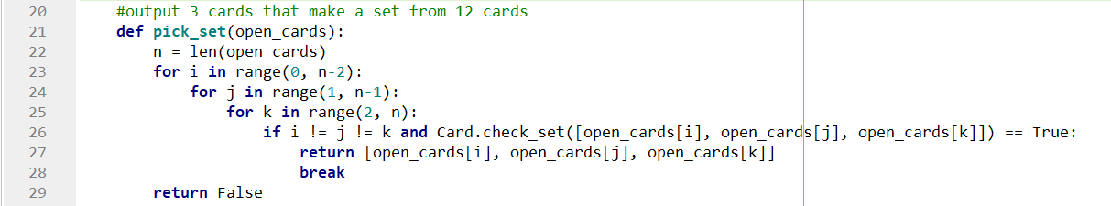
This algorithm is really simple, it just creates every combination of three cards from the given nested list and then checks if these three cards make a SET by inputting it in the ‘check_set’ function, spoken of before. When it has found a SET the loop breaks and the three cards are returned. If it doesn’t find a SET in the nested list it returns ‘False’. If we analyse the time complexity, then we see that the outer loop needs n iterations in the worst case, this also goes for the inner and last loop. Therefore the time complexity becomes . In the best case it only takes one iteration.
Finally we needed a way to randomize cards, the input consist of a nested list with the card lists like ‘’ inside and another list with the corresponding names of the cards like ‘greendiamondempty1’ inside:
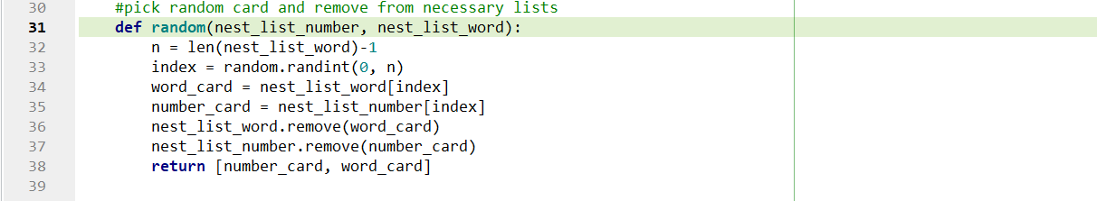
The function returns a random card in the form as discussed above. It also removes the card elements from the corresponding input lists.
This is how we defined the class for the cards, it can pick and check a SET and it can randomize cards. After making this class, we started working on the game itself. Because we have not worked with pygame before, we started by reading and watching tutorials. Soon after we decided to make the cards buttons instead of using an input bar. Therefore we needed another class for the buttons. We looked on the internet on how to make a button class and found a video, we adapted the code from the video to make it work for our cards. The video is listed with our other sources.

Class Button
Again we first initialize the class. We need the coordinates, image and the scale of the button:
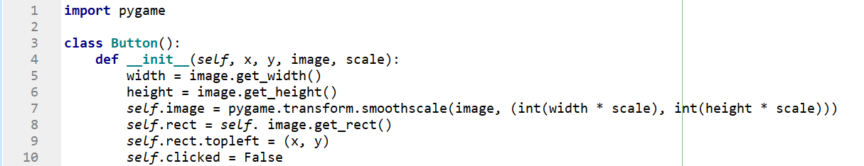
As you can see the width and height are also created. To be able to scale the image we use the ‘transform.smoothscale’ function, this is part of the pygame module. We also make a rectangle from the image so this can be used for the button. The coordinates are the top left corner of the button and we set the clicked variable to ‘False’. Now we need a way to draw the button on screen:
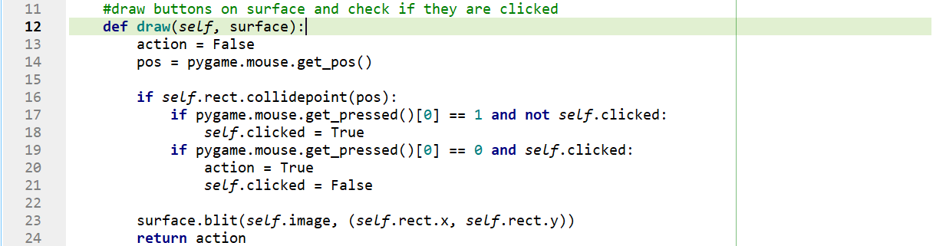
The input variable ‘surface’ is the window you want your buttons on, in our code this window is called ‘screen’. Here ‘action’ is set to ‘False’ this variable will be set to ‘True’ when the button is clicked. ‘pos’ is the position of your mouse on the screen. The first if statement checks if your mouse is hovering over the image/button, than if you click with you left mouse button and the ‘clicked’ variable is ‘False’, it is set to ‘True’. Than if you let go of your mouse ‘action’ is set to ‘True’ and ‘clicked’ is reset. The ‘.blit’ function makes the image appear on your screen and ‘action’ is returned.
This all the code that makes the buttons work. The rest of the code is just long, but not difficult. It consist of many if statements, loading images, creating the cards, creating the buttons and making the timer. All the ‘difficult’ calculations are done in the separate class files, I will explain in short text what each part does.
- Line 1-6: this makes the necessary imports and initializes pygame
- Line 9-16: sets up a few colours for easy access later
- Line 19-25: makes the display and create a few fonts for text on the screen
- Line 28-29: define two user events used for timers on when cards should show on screen
- Line 32-57: load images in python and create buttons for the images
- Line 60-88: create text and rectangles used in the game
- Line 91-101: initialize some time and game variables
- Line 103: start while loop for running the game
- Line 105-203: create a list with all 81 cards in list form, also create a list with the cards in string form. load and make al random card buttons used in the game. Set up the score and deck (stack) count, set all card variables to ‘False’ later used in the game. Reset the game state so that the game can start
- Line 206-209: start event loop and if quit is pressed stop the while loop
- Line: 212-225: if the new cards need to be shown set those card variables to ‘True’ and reset timer
- Line 227-267: the cards that the computer has shown need to be removed, the timer is reset, the computer gets a point, new cards are added and necessary variables are reset.
- Line 278-286: the game is paused when pressing space and help page is shown
- Line 288-291: if the game is over, reset the game by pressing any key
- Line 292-325: fill the screen and if the game is over show the win-, lose-, draw screen
- Line 328-339: show the help screen if help is needed
- Line 340-368: it is the begin screen where you can choose the difficulty
- Line 370-374: you can hit the help or exit button
- Line

